Inferential Statistics – removing the fear factor!
Many students (and some teachers!) have a deep-rooted fear of maths and this creates problems for psychology teachers when trying to teach inferential statistics. My solution is to go back to basics, assume no prior knowledge and demonstrate that there really is nothing to be scared of. If inferential statistics are firmly embedded in practical work they become meaningful and much easier to understand than trying to teach abstract concepts in isolation.
The lobster pot game is a good place to start to reinforcing mathematical skills, especially the concept of probability that is crucial to understanding inferential statistics (https://www.h2g2.com/approved_entry/A912494). I find students, especially boys, really enjoy this activity. Once students have reacquainted themselves with the concept of probability, teaching p<0.05 becomes much easier. I’ve found turning it on its head and dealing with confidence levels e.g. we need to be 95% confident that our results did not occur due to chance helps many students to understand better.
A further area that students struggle with is levels of data: - nominal, ordinal, interval. There are a number of activities you can use to demonstrate the differences, but a really simple one involves laminating pictures of 10 different types of cakes, each with a price on. Firstly, ask students, in pairs, to sort the cakes into categories e.g. fruit cakes, cupcakes, chocolate cakes etc., which demonstrates nominal data. It is worth reiterating that nominal data would usually be displayed in a pie chart. Secondly, ask the students to place the cakes into rank order from favourite to least favourite (ordinal data). Finally, ask students to arrange the cakes in price order (interval data).
On the OCR website is a really useful student workbook for teaching inferential statistics and I think it is really worthwhile to print off a poster of the following graphic for your classroom wall.
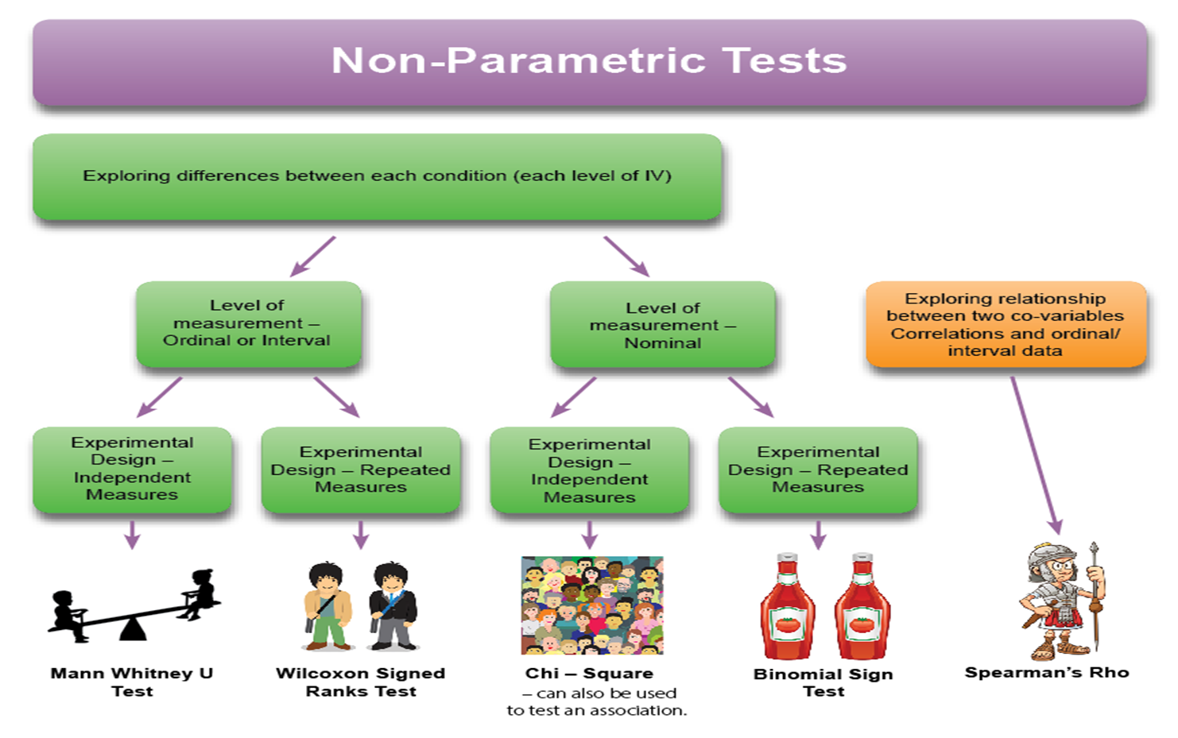

Encourage your students to come up with their own mnemonics to help them remember which test to use when. My student teacher last year came up with an excellent starter/plenary activity to consolidate this. Students had to place the labels in the correct place on a laminated grid. The activity was differentiated as higher ability students didn’t have titles.
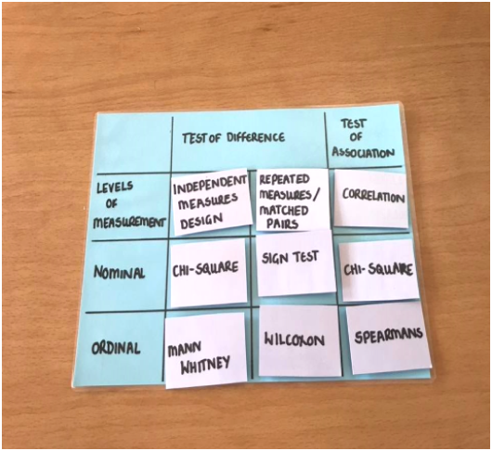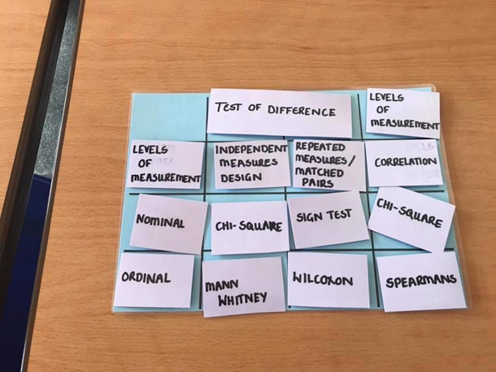
When teaching the calculation of inferential statistics practice really does make perfect. So practice the tests and practice using critical value tables. But I think that it is vital that the practice is in context of practical work. For example, a really simple classroom practical involving a memory test to see if imagery improves recall, would involve two groups of students (test of difference, independent measures design) one shown a list of common words, the other group shown the same words, but with corresponding images, which would generate ordinal data, so the appropriate test would be the Mann Whitney U test. The first step in any calculation is the eye ball test. This simply means does there appear to be any difference, in psychological terms face validity. Calculating the means should demonstrate any difference. Calculating the Mann Whitney U test shows whether or not the difference is significant, in other words it is a large enough difference not to have occurred by chance.
When teaching the calculations remember to reassure the students that they don’t have to remember the formulae, this will always be given in the examination. Similarly, for critical value tables they will be told whether the calculated value needs to be higher or lower. By breaking the calculations down into easy steps and practicing lots hopefully the fear factor can be broken down. My final tip for anxious teachers is to do all your calculations in your planning so you have a security blanket of all the correct answers.
Deb Gajic
CPsychol
AFBPsS
(Links: - www.theatp.org)

